**TASK 3**

1. Write an SQL query to retrieve a list of all orders along with customer information (e.g., customer name) for each order.

**SELECT o.orderID,o.customerId,o.orderDate,o.totalamount,c.firstname from orders o INNER JOIN customers c ON c.customerID= o.customerID**;

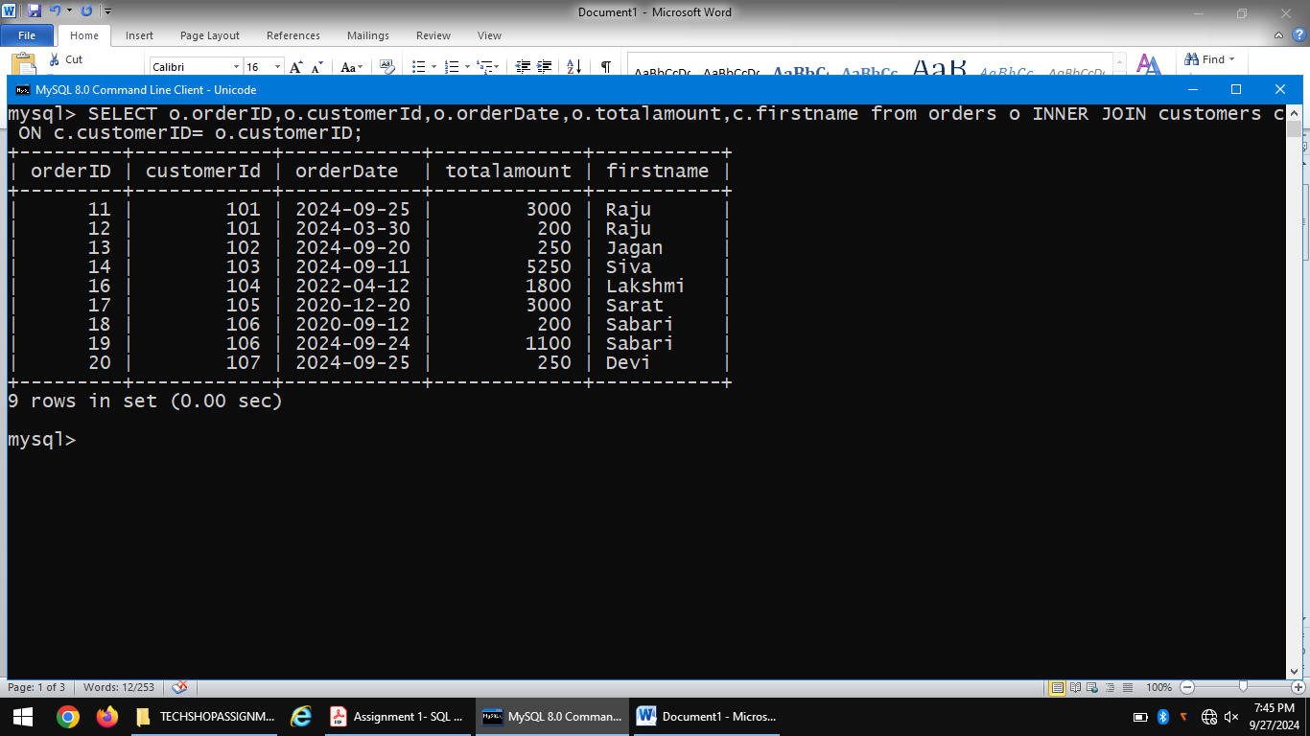

2. Write an SQL query to find the total revenue generated by each electronic gadget product. Include the product name and the total revenue.

**select p.ProductName,sum(od.Quantity*p.price) Total_Revenue from Products p join OrderDetails od on p.ProductID=od.ProductID where p.Category='Electronics' group by p.ProductID order by Total_Reven**

**ue desc;**

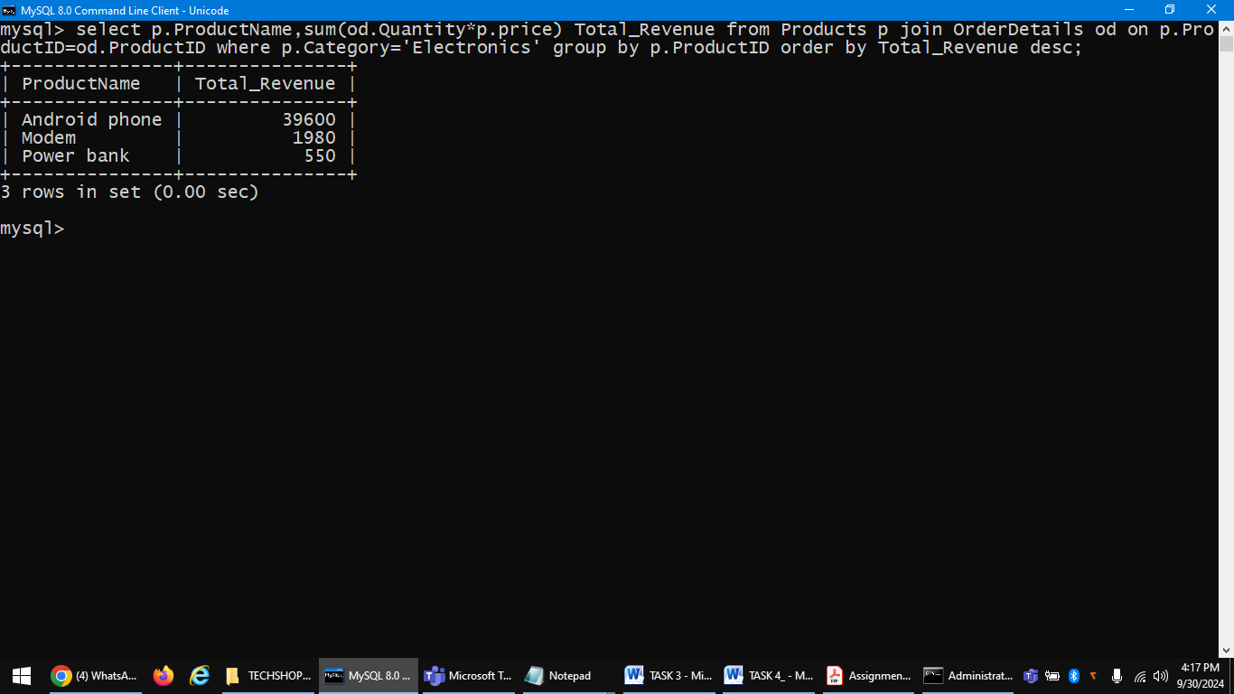

3. Write an SQL query to list all customers who have made at least one purchase. Include their names and contact information.

**SELECT c.firstname,c.email,c.phone from customers c,orders o WHERE c.customerId=o.customerID GROUP BY c.firstname,c.email,c.phone ;**

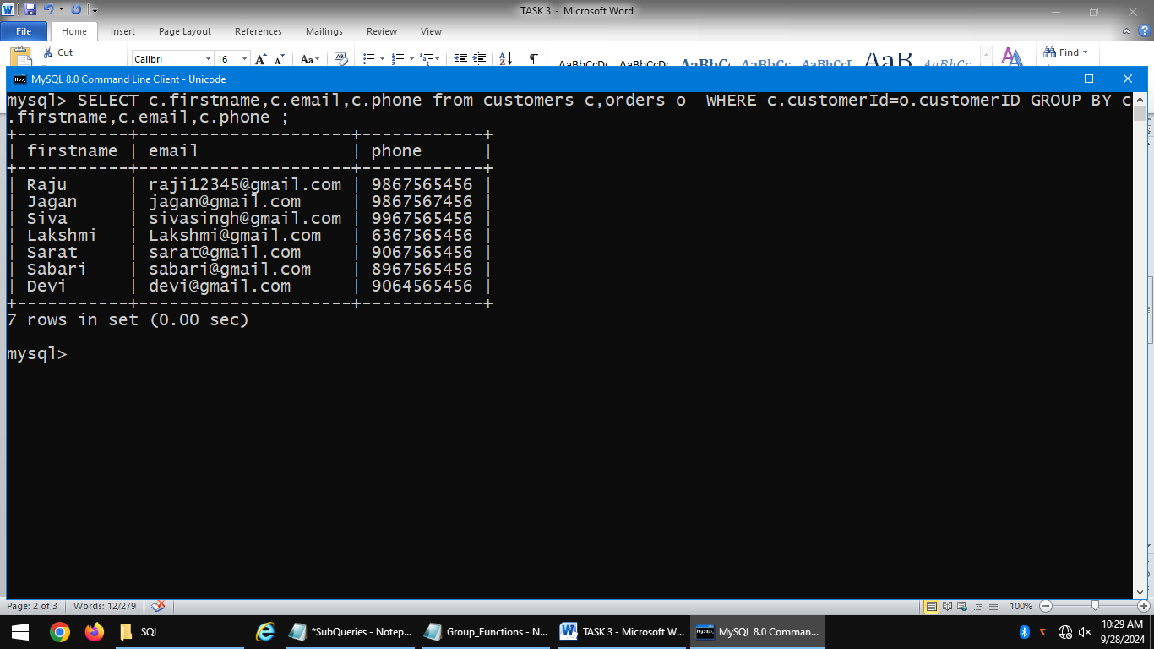

4. Write an SQL query to find the most popular electronic gadget, which is the one with the highest total quantity ordered. Include the product name and the total quantity ordered.

**SELECT p.productname,max(o.quantity) from products p,orderdetails o WHERE P.productid=o.orderid GROUP BY p.productname HAVING max(o.quantity**);

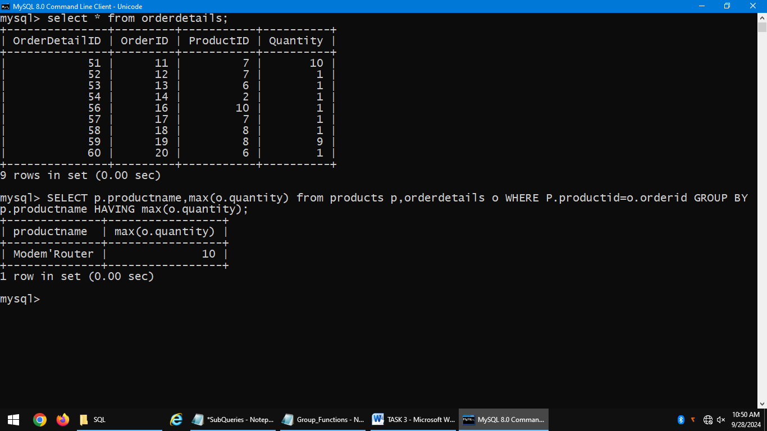

5. Write an SQL query to retrieve a list of electronic gadgets along with their corresponding categories.

**SELECT productname,category from products;**

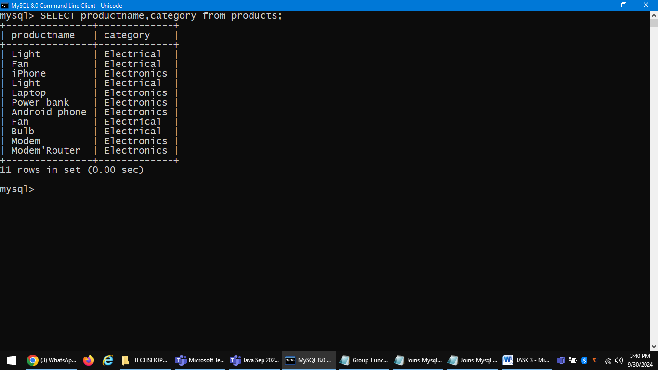

6. Write an SQL query to calculate the average order value for each customer. Include the customer's name and their average order value.

**SELECT c.firstname,avg(o.totalamount) from customers c,orders o WHERE c.customerid=o.customerid GROUP BY c.firstname order by c.firstname** ;

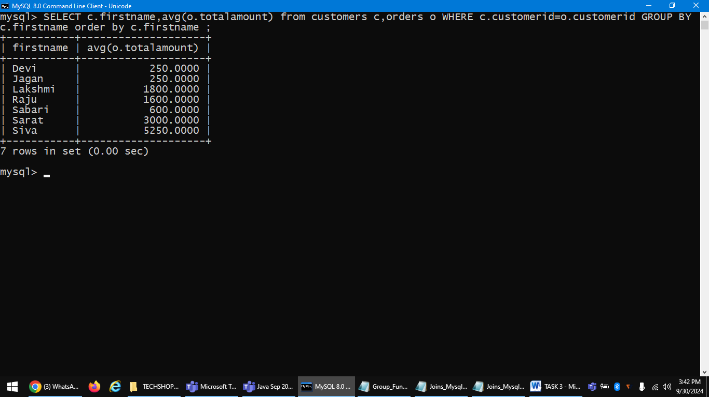

7. Write an SQL query to find the order with the highest total revenue. Include the order ID, customer information, and the total revenue.

**SELECT c.email,c.firstname, o.orderid, o.totalamount AS Total_Revenue FROM customers c INNER JOIN orders o ON o.customerid = c.customerid WHERE o.totalamount = (SELECT MAX(totalamount) FROM orders);**

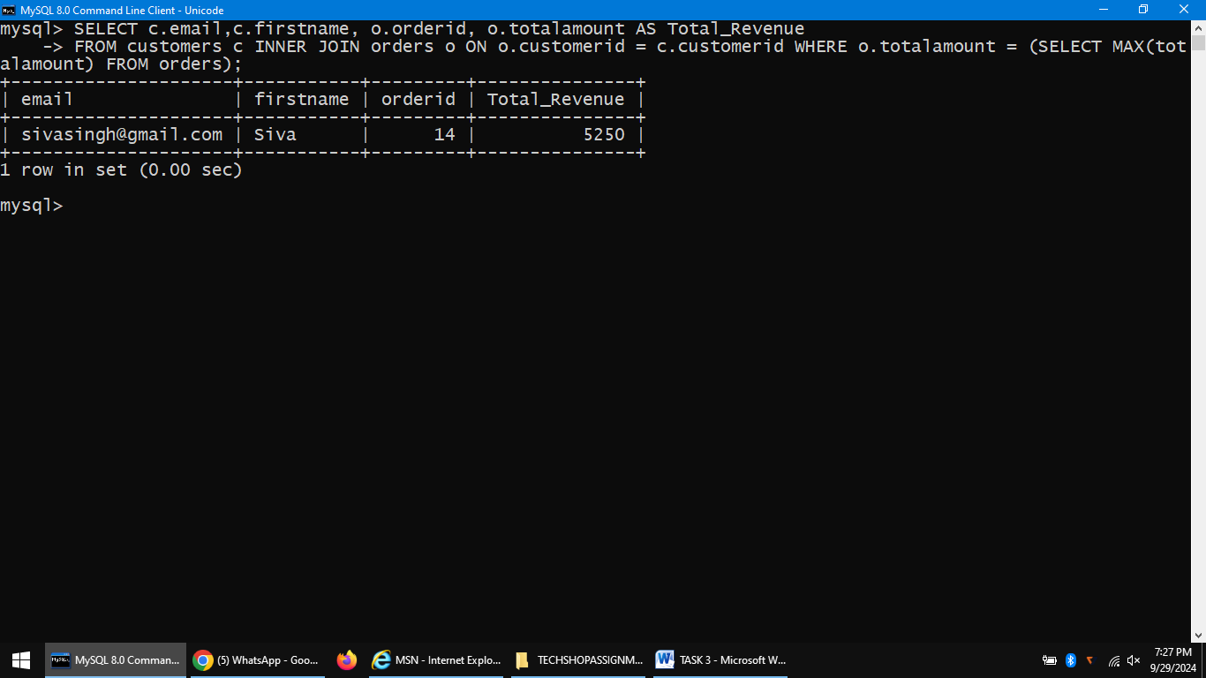

8. Write an SQL query to list electronic gadgets and the number of times each product has been ordered.

**SELECT p.productname,count(o.productid) as nooforder from orderdetails o, products p WHERE P.Productid=o.productid GROUP BY p.productname ORDER BY p.productname;**

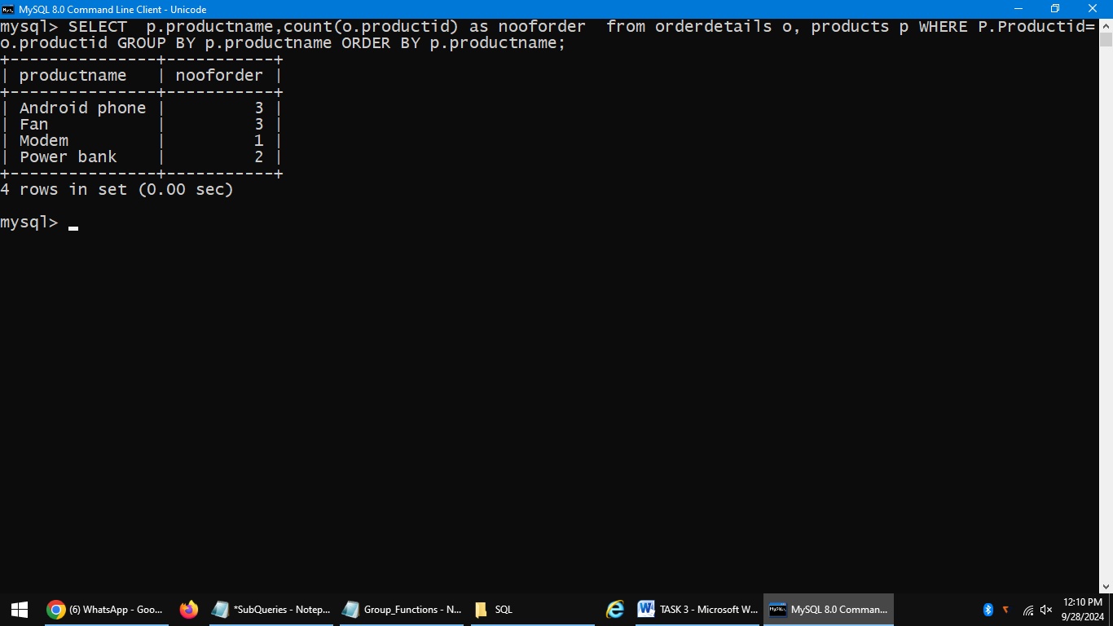

9. Write an SQL query to find customers who have purchased a specific electronic gadget product. Allow users to input the product name as a parameter.

**select FirstName from Customers where CustomerId in (select CustomerId from Orders where OrderId in (select OrderId from OrderDetails where ProductId in (select ProductId from Products where ProductName='Android phone')));**

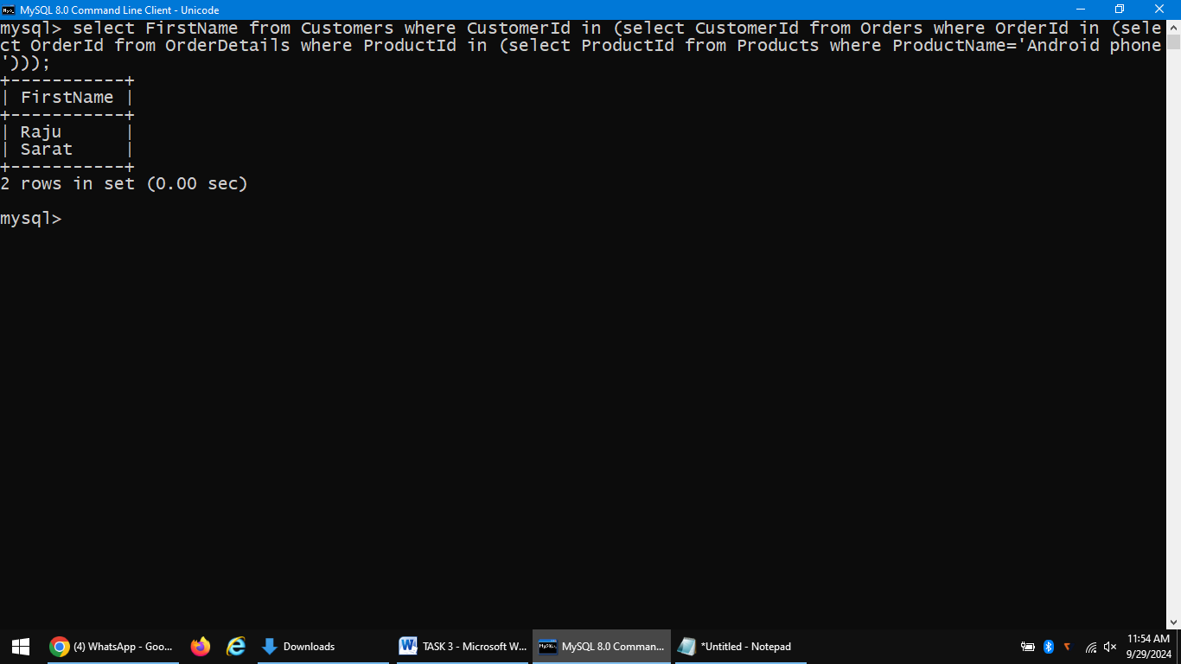

10. Write an SQL query to calculate the total revenue generated by all orders placed within a specific time period. Allow users to input the start and end dates as parameters.

**Select sum(IFNULL(o.totalamount,0)) as totalrevenue from orders o WHERE O.orderdate BETWEEN 22-06-2020 AND 19-09-2024;**

